|  |  |
| --- | --- |
|  |  |
|  |  |

**Assignment1: WEB DEVELOPMENT**

|  |
| --- |
| **[REPORT OF WEB DEVELOPMENT]** |
| [Type the abstract of the document here. The abstract is typically a short summary of the contents of the document. Type the abstract of the document here. The abstract is typically a short summary of the contents of the document.] |

PRATAP DONG

UN ID: 17421488

SUBMISSION DATE: (9th April)

**Contents**

Getting Started………………………………………………………………………… 2

Designs……………………………………………………………………………….. 2

Wireframes……………………………………………………………………. 2

Wireframe for Home page…………………………………………….... 2

Wireframe for CV page………………………………………………… 3

Wireframe for Contact page……………………………………… 4

Wireframe for Biography page…………………………………………. 5

Wireframe for Mobile Design…………………………………………… 6

Prototypes………………………………………………………………….. 7

Style tile…………………………………………………….. 7

Logos……………………………………………………………………… 8

Evidence of good practice……………………………………….……………… 9

Page load speed…………………………………………. ………………. 9

Validation of html……………………………………………. ………………………10

Validation of CSS…………………………………………………………………. 11

Progression over 12 weeks……………………………………………………….. 13

(1-4) weeks…………………………………………………………………. 13

(4-8) weeks…………………………………………………………………. 14

(8-12) weeks……………………………………………………………….. 16

Conclusion………………………………………………………………………….. 17

**Getting Started**

Before making the website, I have visited many websites to take idea. But I haven’t copied them. I have used HTML and CSS coding in atom to make the website. Furthermore, I haven’t used any type of application which generates code automatically. I have created 4 HTML including Home, CV, BIOGRAPHY and CONTACT and I have used individual CSS file for each HTML. The websites that I have visited to grab the ideas for making my own website are as follows:

* <http://www.kantipur.ekantipur.com/>
* <http://www.thehimalayantimes.com/>
* <http://www.gorkhapatraonline.com/>
* <http://www.kathmandupost.ekantipur.com/>

**Designs**

I have designed my website before I start to code HTML and CSS for web development. The wireframes that I have made for my website are listed below:

**Wireframes**

There are five wireframes of my website. One is for mobile design and others are for Home page, Biography page, CV page, Contact page.

**Wireframe for Home page**

I will be including heading part, body part and footer in my first page i.e. home page. In heading part there will be my name and UN id and my name will always link to home page. In body part, I will be including my picture and about the webpage. In footer part, there will be some images.

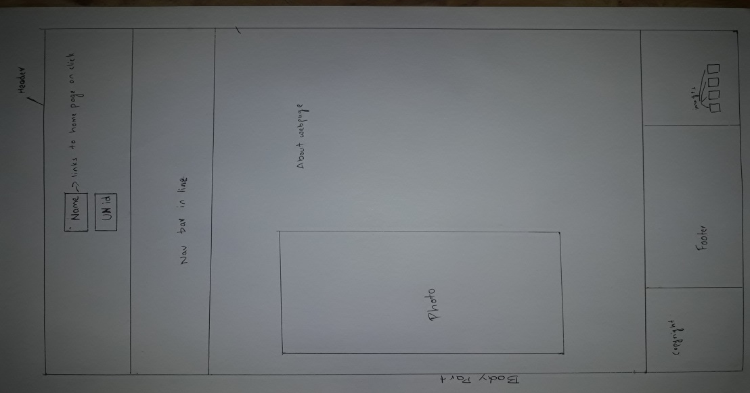

**Wireframe for CV page**

I have designed header and the footer as the home page in CV page. But, the body part is different. I am not going to include any photo in body part.

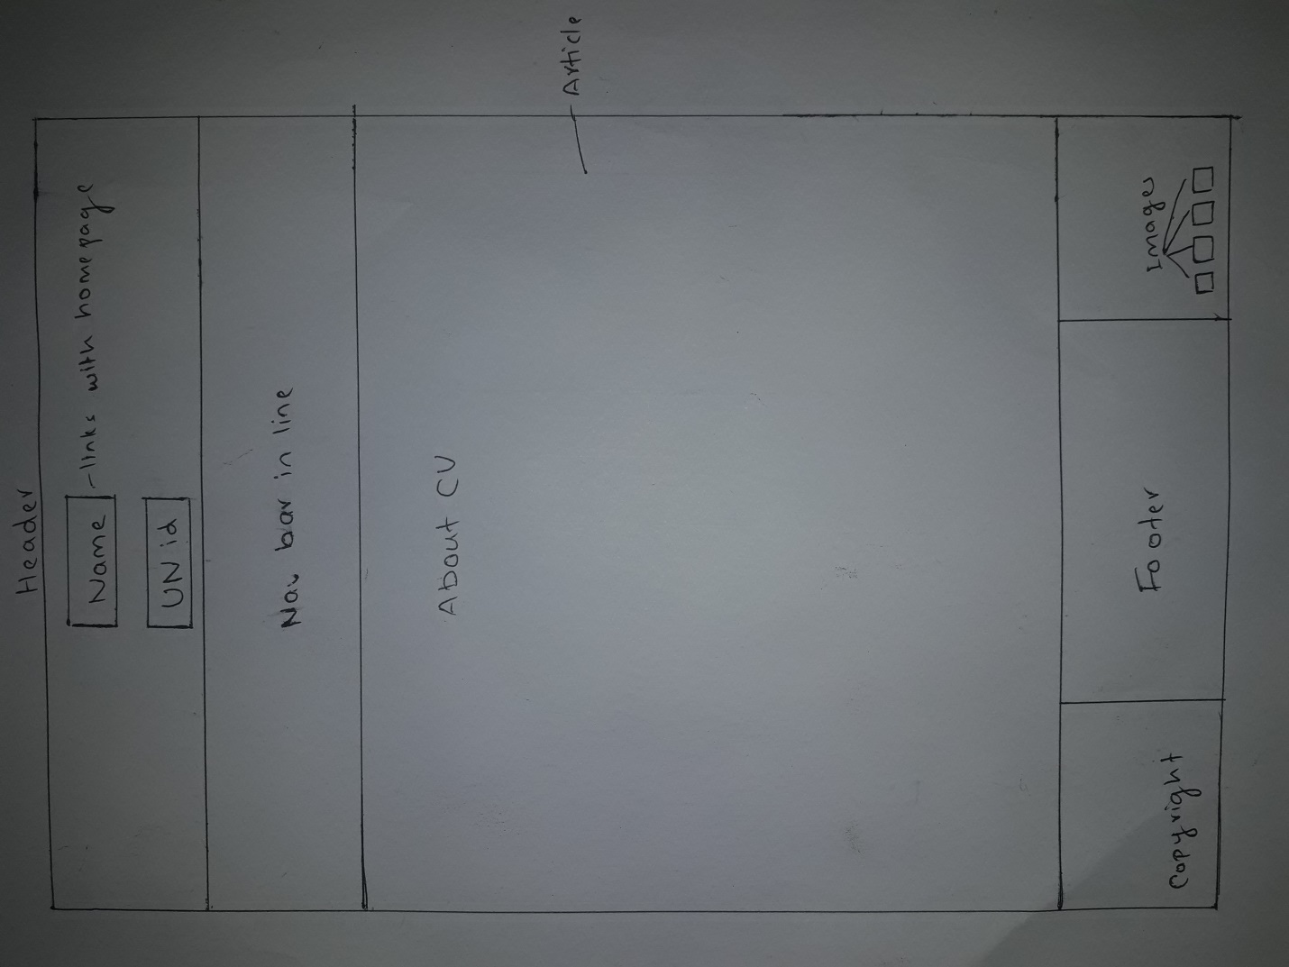

**Wireframe for Biography page**

In this page I will be including aside and article In the main body photo. Aside will be in left side where as the article part will remain in right side. I will include one photo in aside and biography in article part. 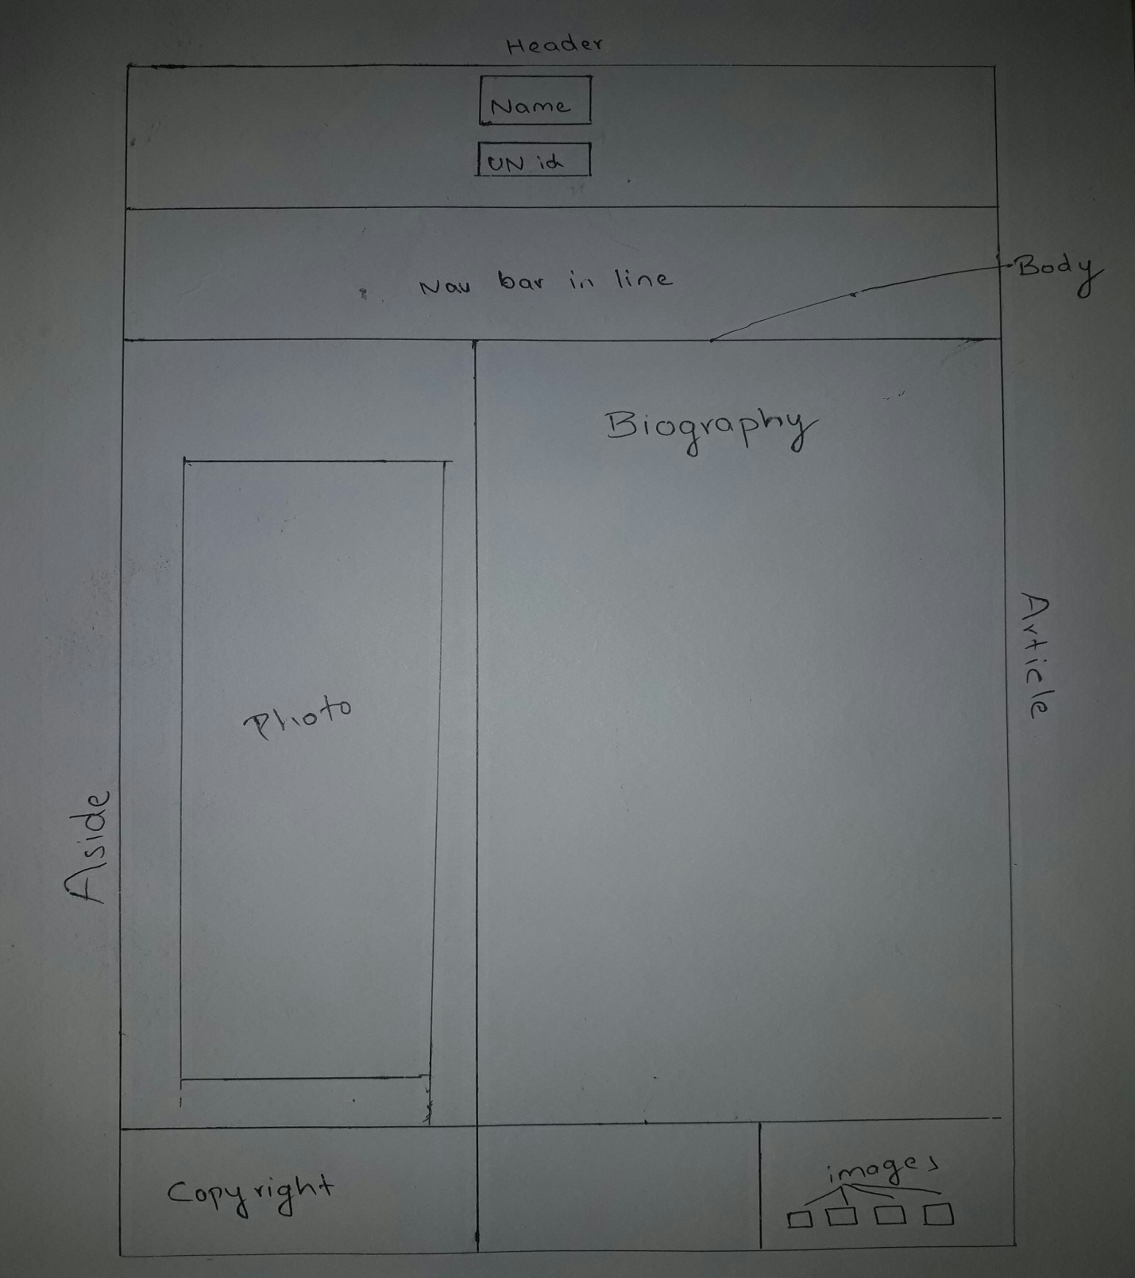

**Wireframe for Contact page**

The contact page will remain same as biography page.But, in article part I will include form including first name, last name and message.

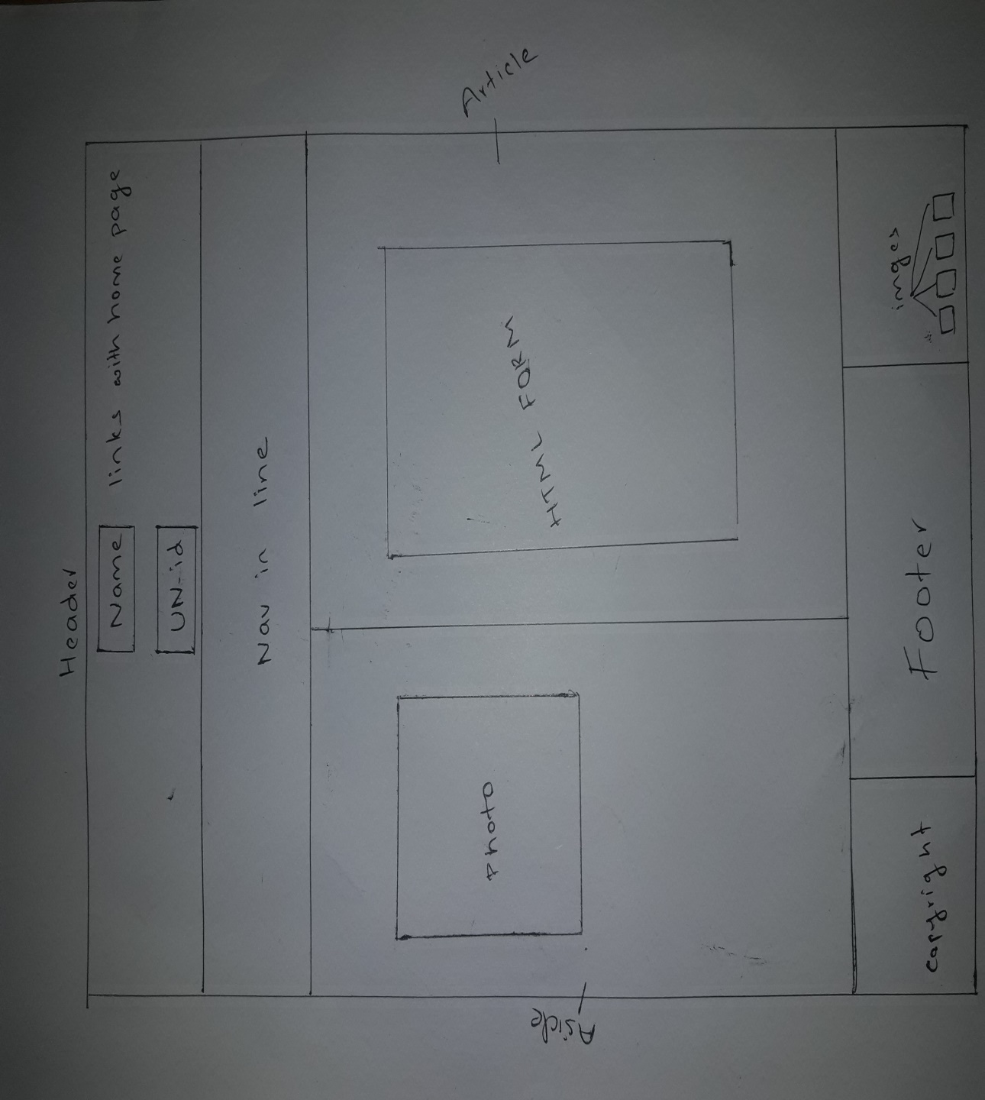

**Wireframe for Mobile Design**

The wireframe for the mobile screen will be like :

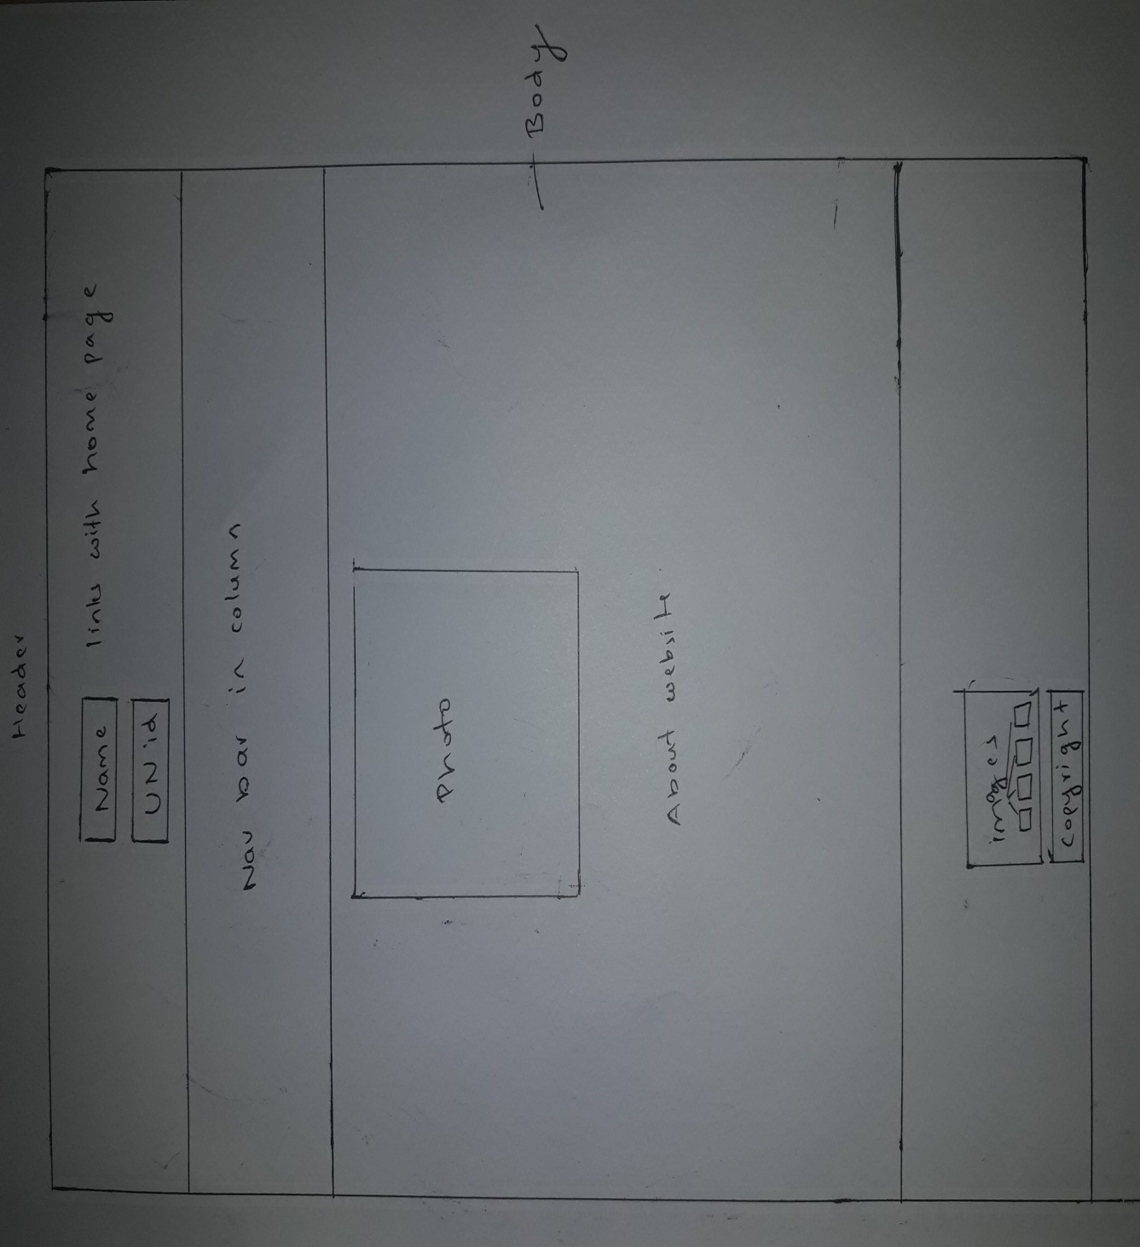

**Prototypes**

**Style tile**

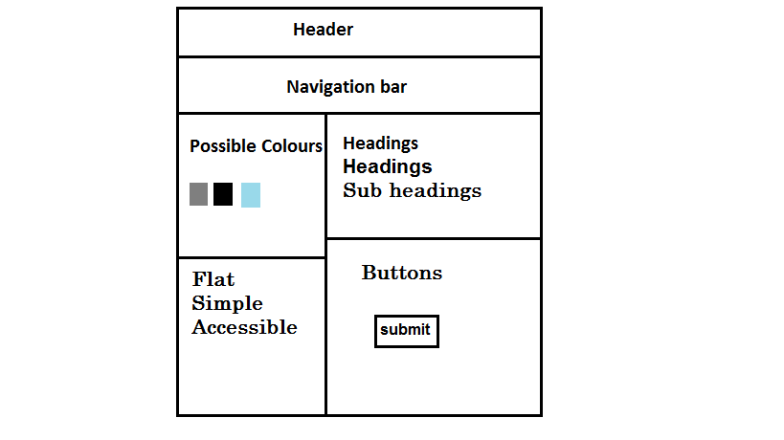

**Logos and images**

The logos that I have used in the web page are as follows:



   

I have used this image as my background image



**Evidence of good practice**

To know the quality of my website I have gone through different approach. I have tested the speed of my website and validate CSS and html in order to make my website error free code.

**Page load speed**

I checked the speed of my website in pingdom.com. The performance grade of my website is 88 load time is 511ms and is faster than 97%. And the evidence for this is given below in picture:

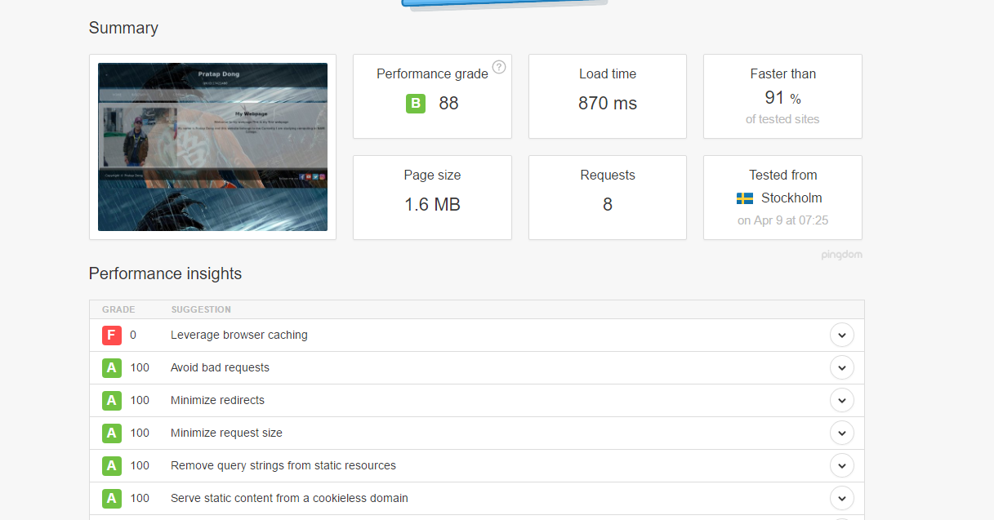

**Validation of Html**

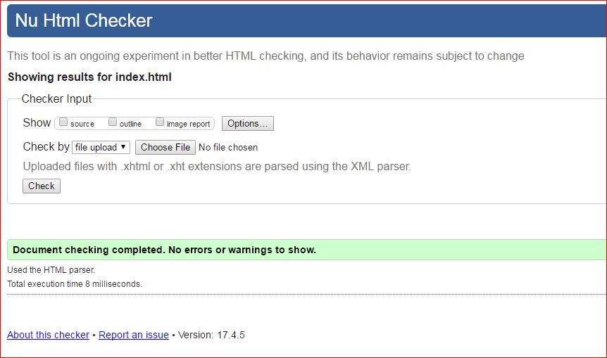My webpage is free of error codes as I have checked my files in Nu Html Checker. The following images are the evidence that my webpage is free of error codes.

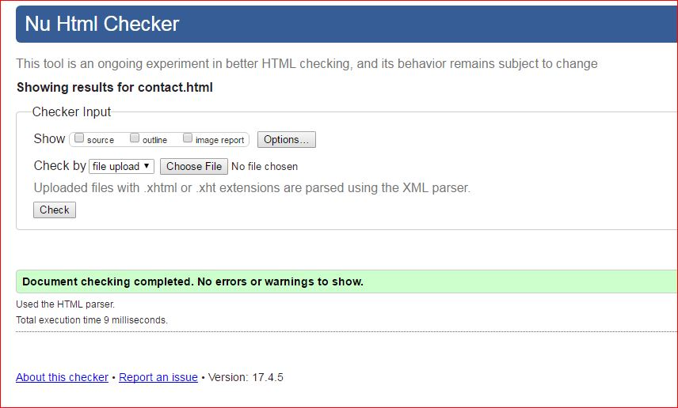

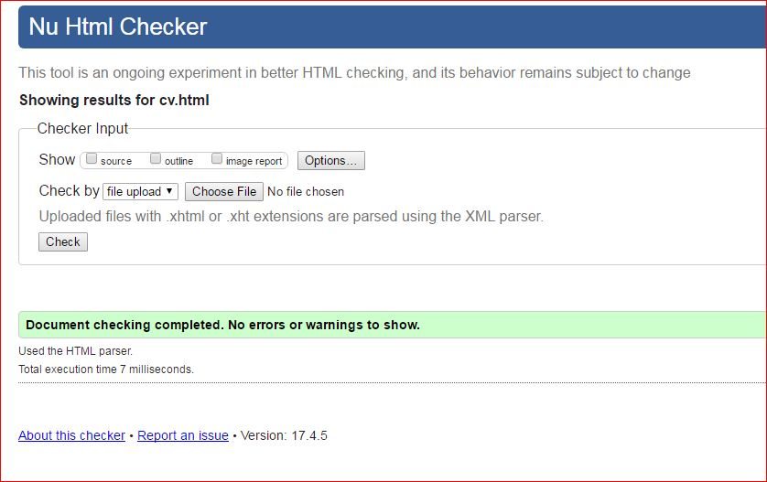

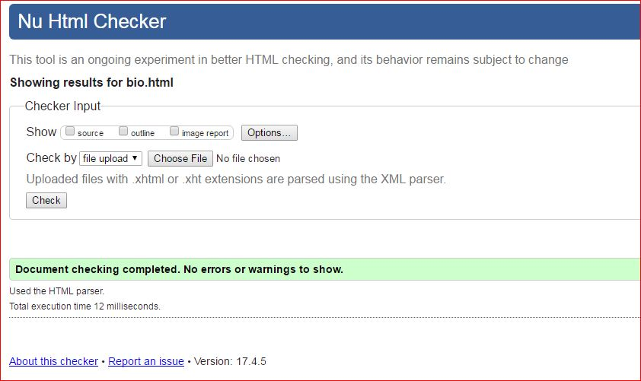

**Validation of CSS**

The code for css is also error free and the evidence is given below:

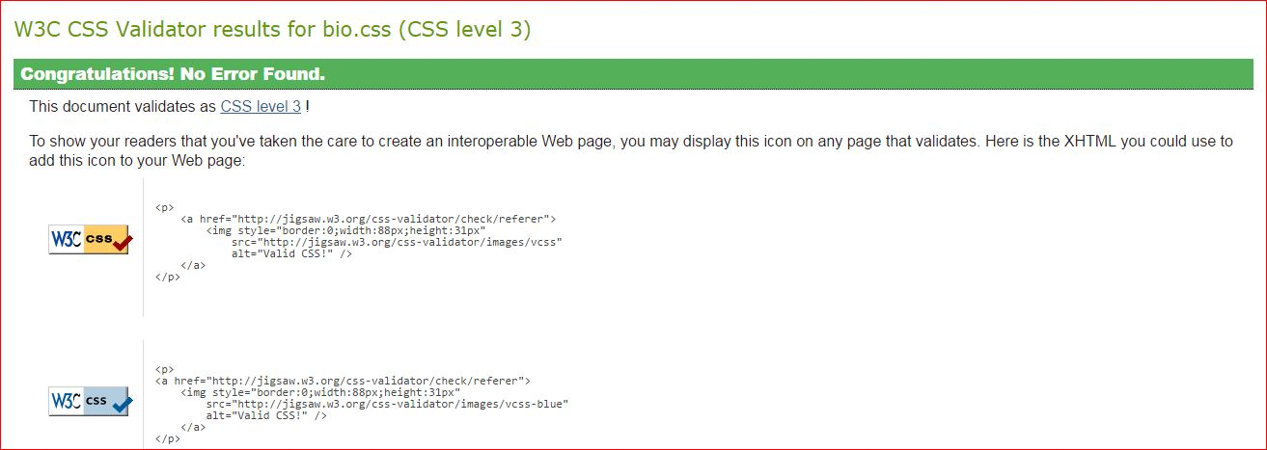

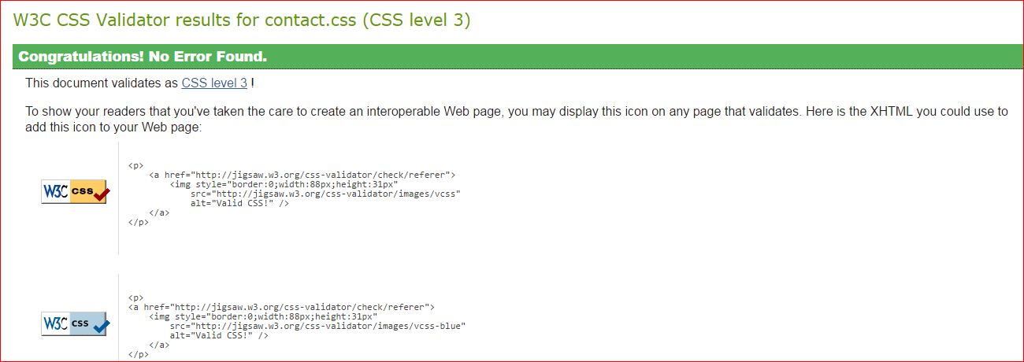

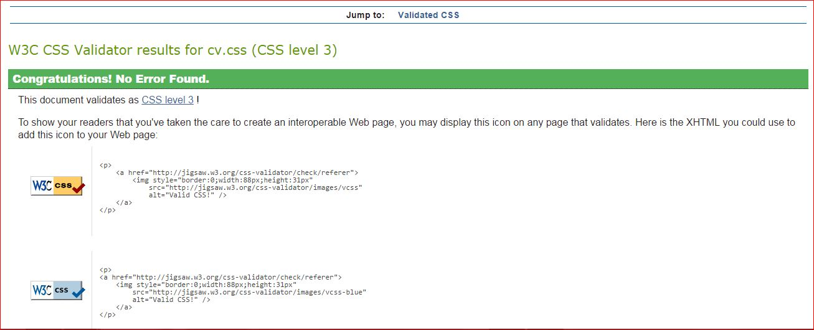

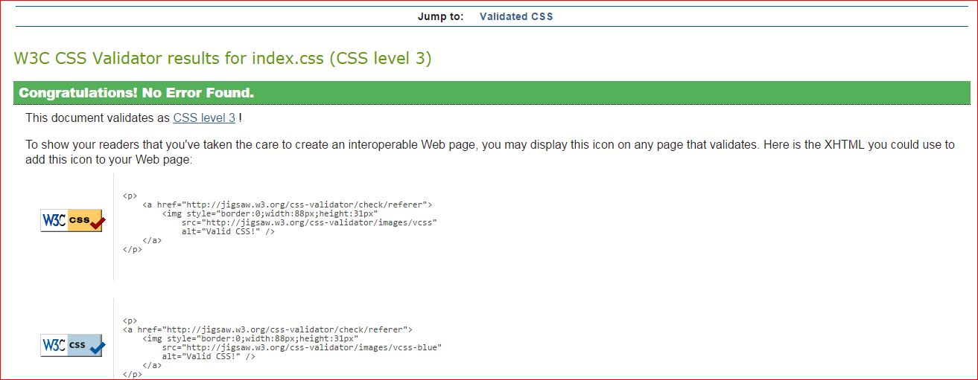

**Progression over 12 weeks**

**Week 1-4**

In the very first week, I have designed the header part. I included header and navigation bar in the head part. I made the Navigation bar responsive.

After designing header part, I have designed another part i.e. footer part. In footer part there are two parts. In the first division I have included copyright, in the second part there are social sites images. And I have finished header and footer part within 4 weeks. 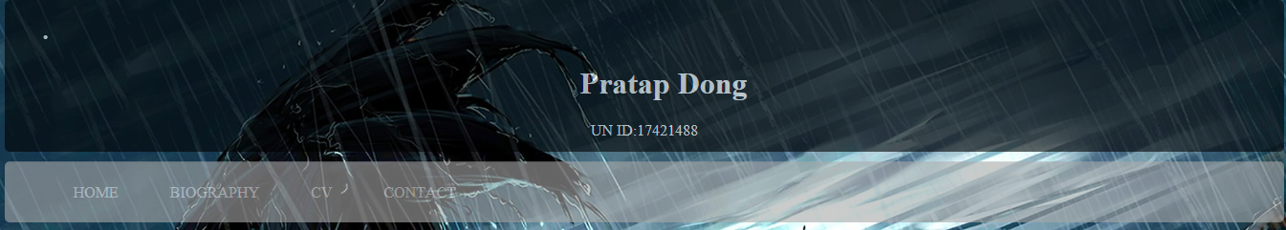



**Week 4-8**

I took almost 4-8 weeks to design the body part of all the pages. I have included one photo and the description about myself in the body part of the home page.

In the biography page I have divided the main body into two parts they are: aside part and article part. In aside part I kept my photo whereas, in the article part I have kept my own biography.

In CV page I haven’t divided the body part. It includes article only.

Contact page is similar as biography page which includes aside part and article part.

Home page contents:

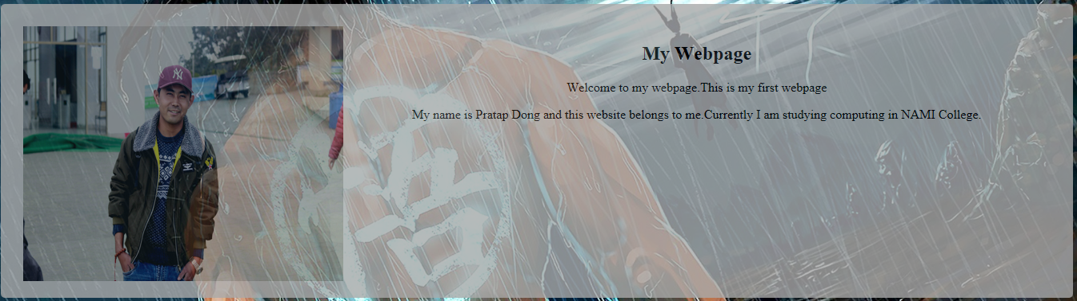

CV page contents:

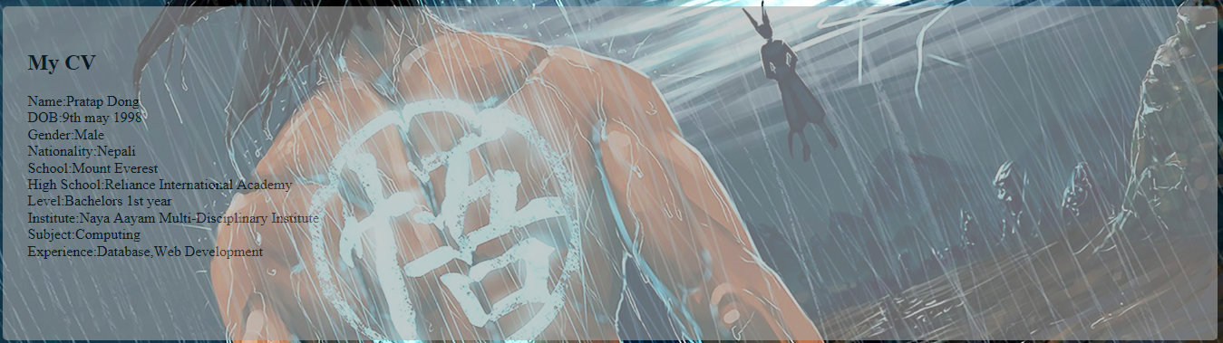

Content of contact page:

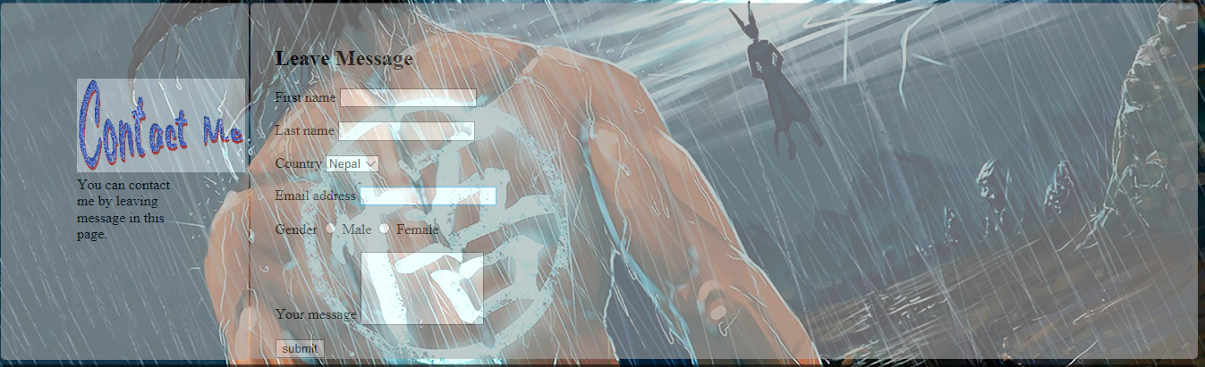

Content of bio page:

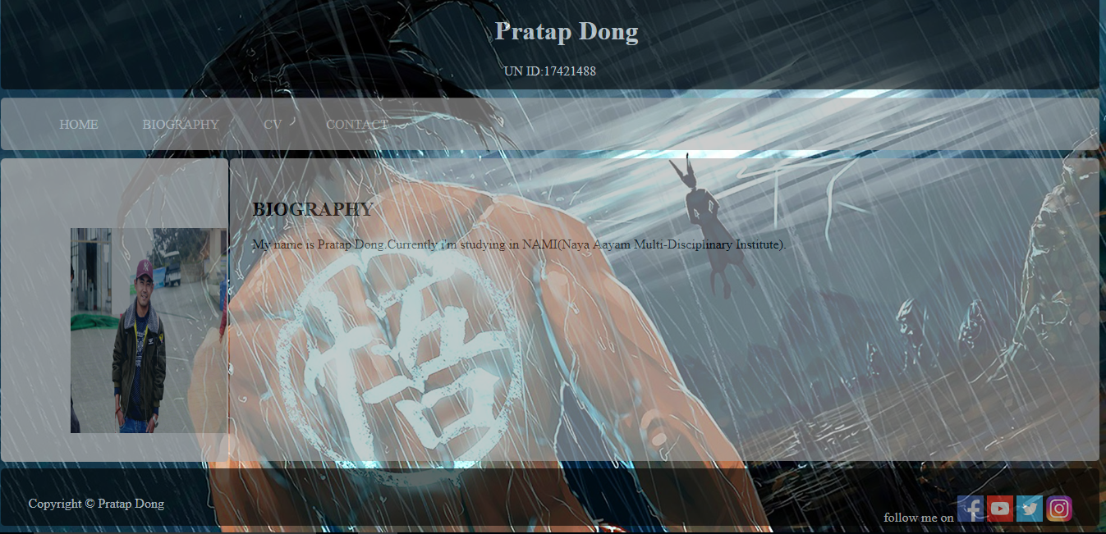

**Week 8- 12**

After designing all the pages, I have spent my time in mobile designing. I have made the website responsive. This website will support in android mobile as my website will support the maximum width of the 480 pixel. In the mobile design, the whole body will display in column. My website for mobile design will look like the following picture

Mobile design:

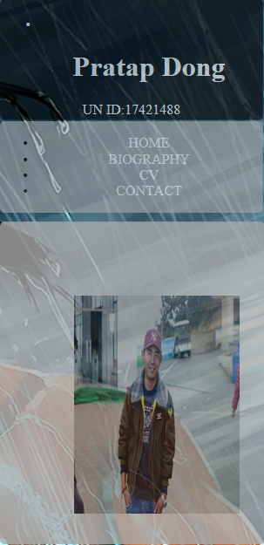

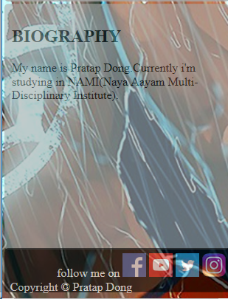

**Conclusion**

This website was completed in 12 weeks. It is error free code as it is validated by NU W3C validator. It is responsive in nature and it will display in android mobile. Furthermore, It is easy to use , accessible and faster .